Designing Weatherproof Enclosure for Use in ‘NetCams’ Camera Trap

Zalman Lipschitz

Independent Study

Class of 2022

University of Massachusetts, Amherst

Department of Mechanical and Industrial Engineering

Fall 2021

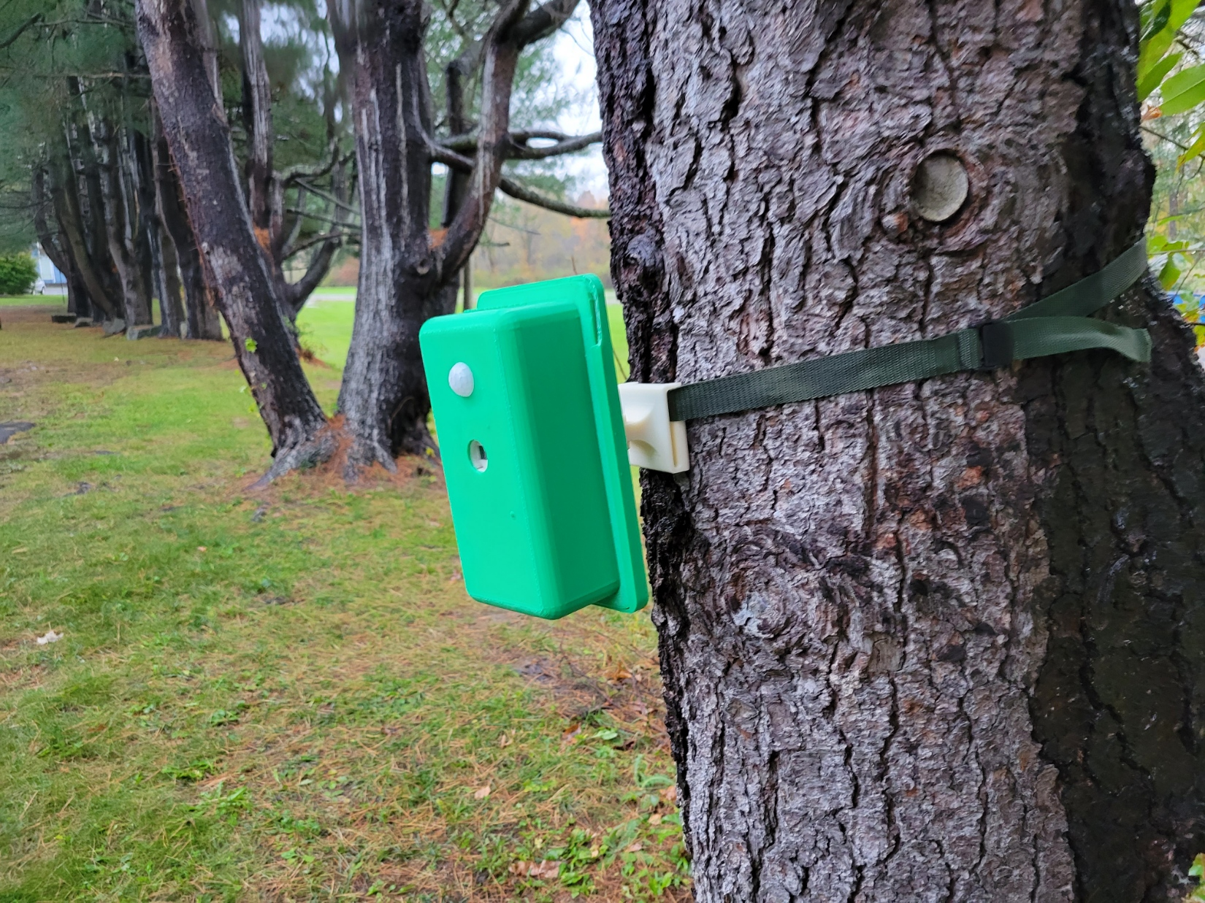

**Abstract**

During the academic year of 2020, a group of electrical and computer engineering students at the University of Massachusetts Amherst undertook a challenge for their senior design project (SDP): a camera trap. At its core, a camera trap is a system of cameras that all simultaneously take a picture when enough of them sense something (e.g., an animal) walk past. The team delivered on this goal but fell short on one aspect of the design: the enclosure. This aspect became my independent study objective. Working with Professors David Schmidt and Duncan Irschick, I spent the fall 2021 semester designing an enclosure that could withstand days or weeks of being left outside while protecting the electronics on the inside. Due to our combined efforts, we have a robust camera trap system dubbed ‘NetCams’ but there is still room for improvement.

**Introduction**

You’ve seen wildlife cameras – the boxes that hang on trees and take pictures of curious deer walking past. This project takes that idea a step further. Instead of one camera getting one photo, a camera trap is a system of cameras that all communicate and take simultaneous photos of the same animal from different angles, as shown in *Figure 1*. The intent of NetCams is that the photos can then be processed through photogrammetry software to make a 3D model of whatever stepped into frame.

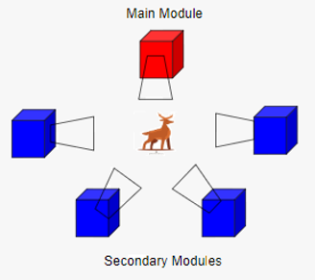

Figure 1: System Diagram

There are several aspects to a system like NetCams. First and foremost, the system needs to recognize when an animal is present; the SDP team chose to use a Passive Infrared (PIR) sensor to detect the body heat that animals give off. These sensors are cheap, don’t use much energy, and are easy to implement. Once an animal is sensed, the secondary units need to communicate with a main unit that triggers a simultaneous photo when more than 2/3 of the units sense an animal. The team chose to communicate over a wireless access point that is set up on the master. When the main unit send the message to snap a photo, each unit needs to take a picture; this requires a camera and a computer to control the camera. The computer that met the needs of the system is a Raspberry Pi Zero WH (RPi). There are no hardware differences between the main and secondary units. In each unit there is an RPi, a camera, a PIR sensor, and a battery that can sustain the system for a minimum of 3 days.

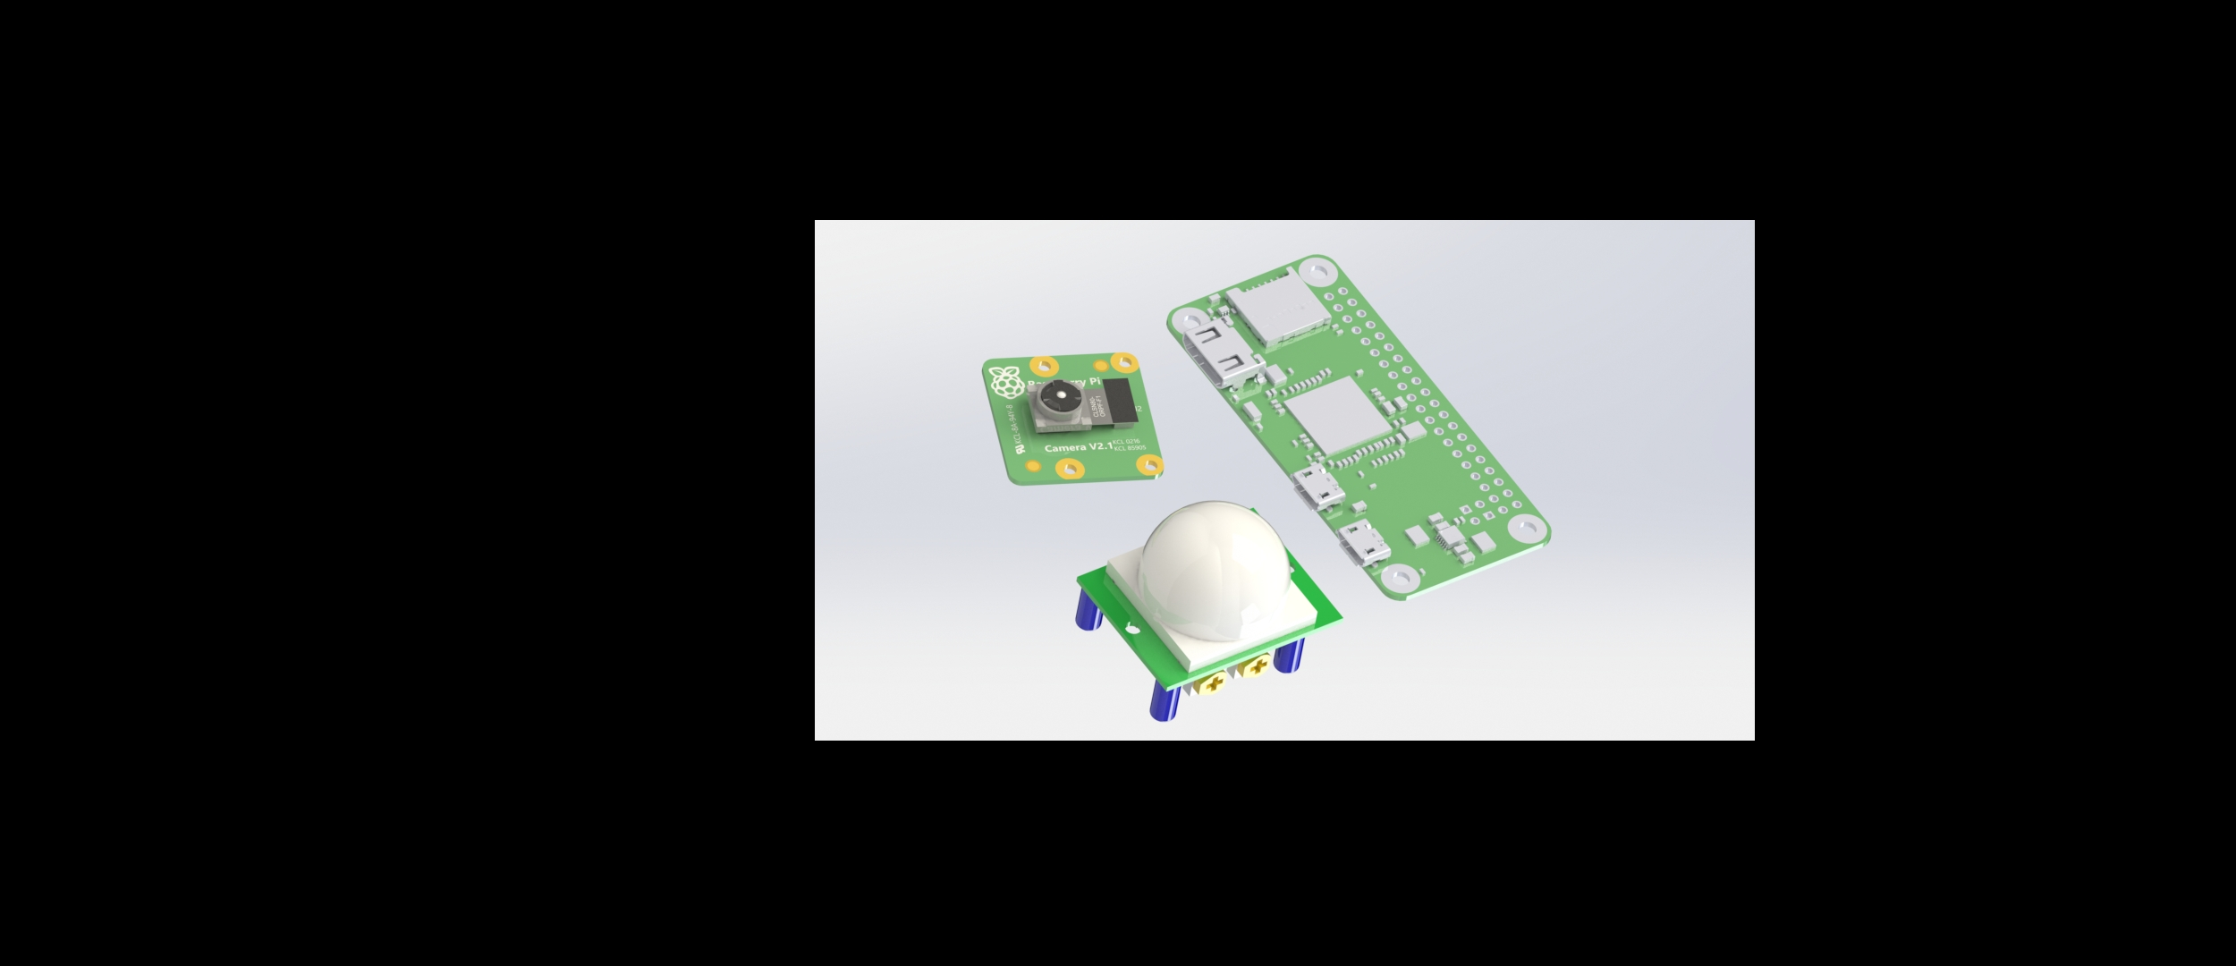

Pi Zero WH

PIR sensor

Pi Cam

Figure 2: The hardware required to be inside the enclosure. Not including battery.

The NetCams system is intended to be deployed by a biologist then retrieved days or weeks later. While deployed, the system is sensitive to moisture, dust, and tampering by animals. In addition to protecting from these, it must be easily manufactured, repeatable, cost-effective, and not break under normal use conditions. There are specific challenges with every aspect of the mechanical design. Throughout the course of the independent study, these challenges were all overcome, and most deliverables were met.

**Prior Solution**

While the SDP team didn’t end up with a functional enclosure, it was not for lack of trying. Shown in *Figure 3*, they used Fusion 360 to create what is essentially the first version of what exists now. It had several weak points: the size, the hinges, the window, the latches, the seal, and the method of securing it in the field. The most important thing to note is these were not elementary design errors; they did a great job for electrical and computer engineers with little to no experience with CAD or 3D printing.

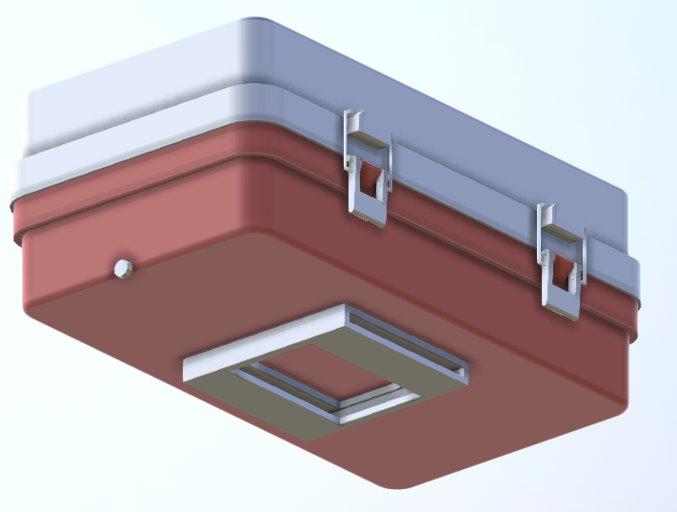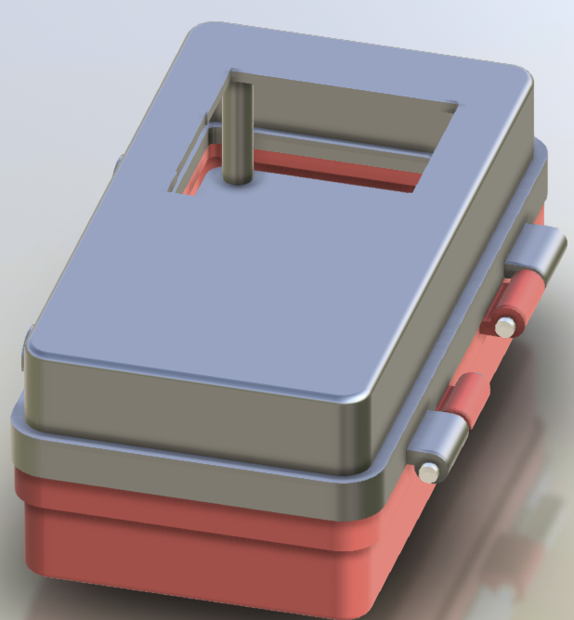

Figure : Preliminary Design by SDP Team

1. **Known Issues**
2. The enclosure was too small to fit the larger of the 2 battery options, meaning increasing size yielded a much longer battery life.
3. The hinges were designed with no real way to fix them in place; the shafts were just printed pieces of plastic. This resulted in a loose feel and poor seal when closed. Additionally, they were relatively weak.
4. The window had two jobs: let IR light through for the PIR sensor and let visible light through for the camera. The SDP team chose to use a piece of Lexan (polycarbonate) as the window. There were two problems with this: Lexan is not IR transparent, and they used electric tape to fix it in place. This resulted in an inability for the sensor to see animals but also a barely weatherproof seal. Additionally, the team had removed the Fresnel lense [1] from the PIR sensor, making it behave poorly and inconsistently.
5. The latches were simply too small; 3D printed ABS parts that size can’t stand up to the forces the latches would see. Additionally, the team didn’t know what do use for the loop, so they used a piece of stripped electric wire, a not-so-elegant solution. This resulted in a poor seal.
6. While the hinges, latches, and the window already contributed to a poor seal, the interface between the two halves of the enclosure did a very poor job keeping things out. While the assembly instruction refers to a rubber O-ring, there isn’t one sourced, and the prototype only had an ABS seal.
7. Lastly, to use the system, the units need to be secured and pointed at a common point. The method of securing these boxes was a stationary belt loop. This meant that the box was always parallel to the branch it was secured to, making it difficult to point multiple units at the same point.

**New Design**

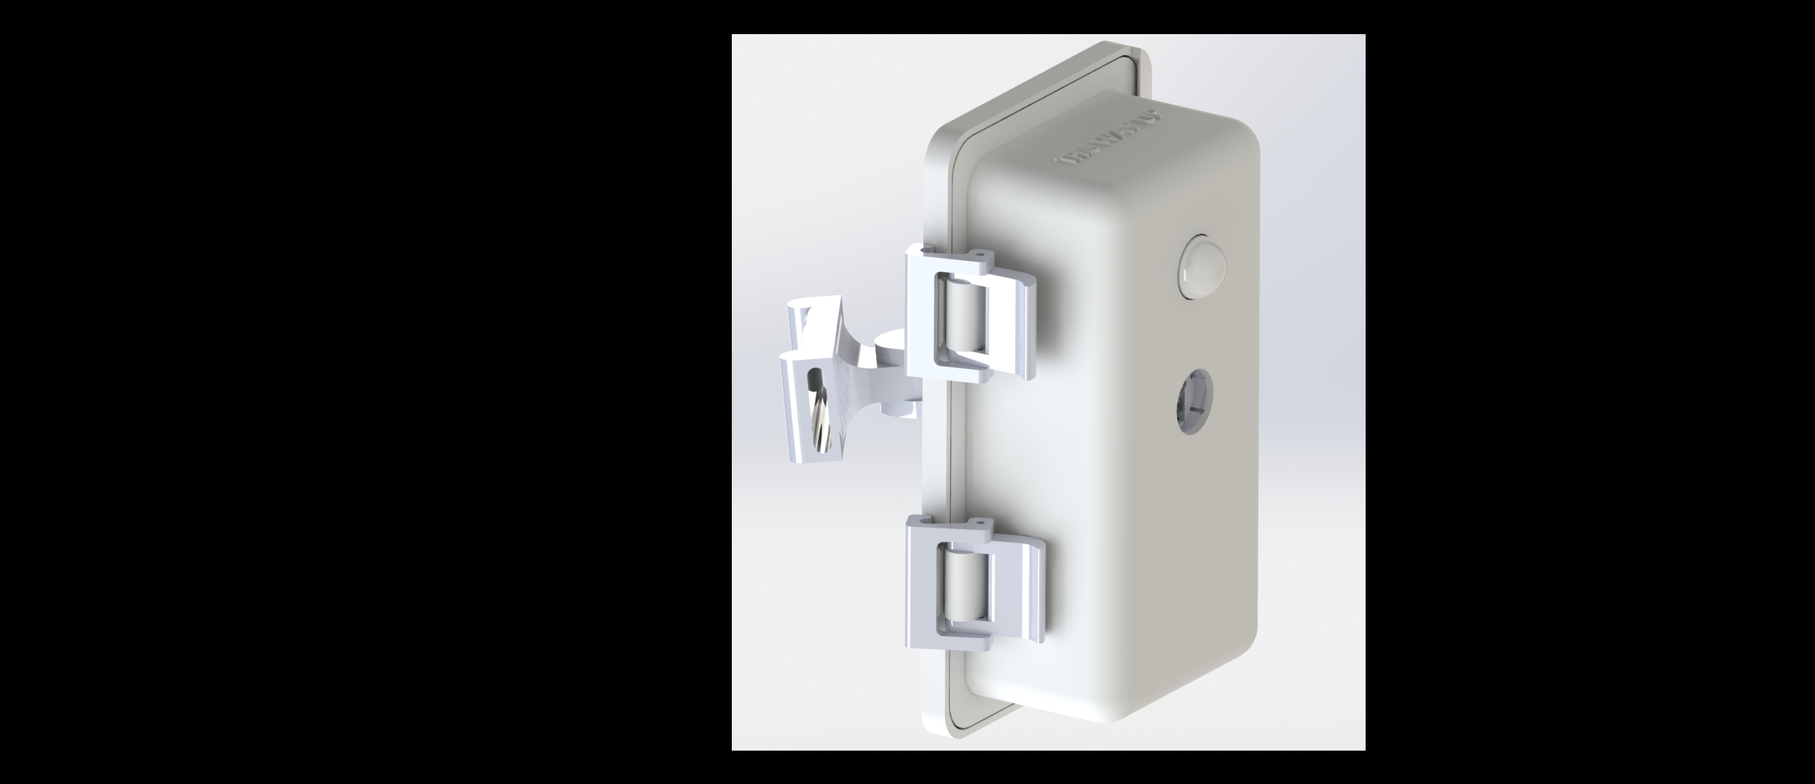

Camera

PIR Sensor

Figure 4: Render of Full Enclosure

Treating the unit like a system, I considered the known issues, set deliverables for myself, and researched existing solutions. I attempted to solve each problem individually and integrate them into each other where it made sense. This approach made it easy to manage the overall design while still paying attention to smaller details.

The first part of the system that I tackled was the window. It needed to transmit IR light, visible light, and be water, dust, and UV resistant. Looking at the datasheet for the PIR sensor, I gathered that the wavelength of the light that triggers it is around 10 ± 2.5 µm [2]. I spent time researching which materials let that wavelength through (*Figure 5*). Eventually, I realized that the Fresnel Lens that comes with the PIR sensor is made from HDPE. Shown in *Figure 4*, I decided to use the lens itself as the window for the PIR sensor and just use optically clear polycarbonate as the window for the camera. To create a seal, there is silicone sealant between the enclosure and the windows, and they are held in compression with screws. Two problems, two solutions.

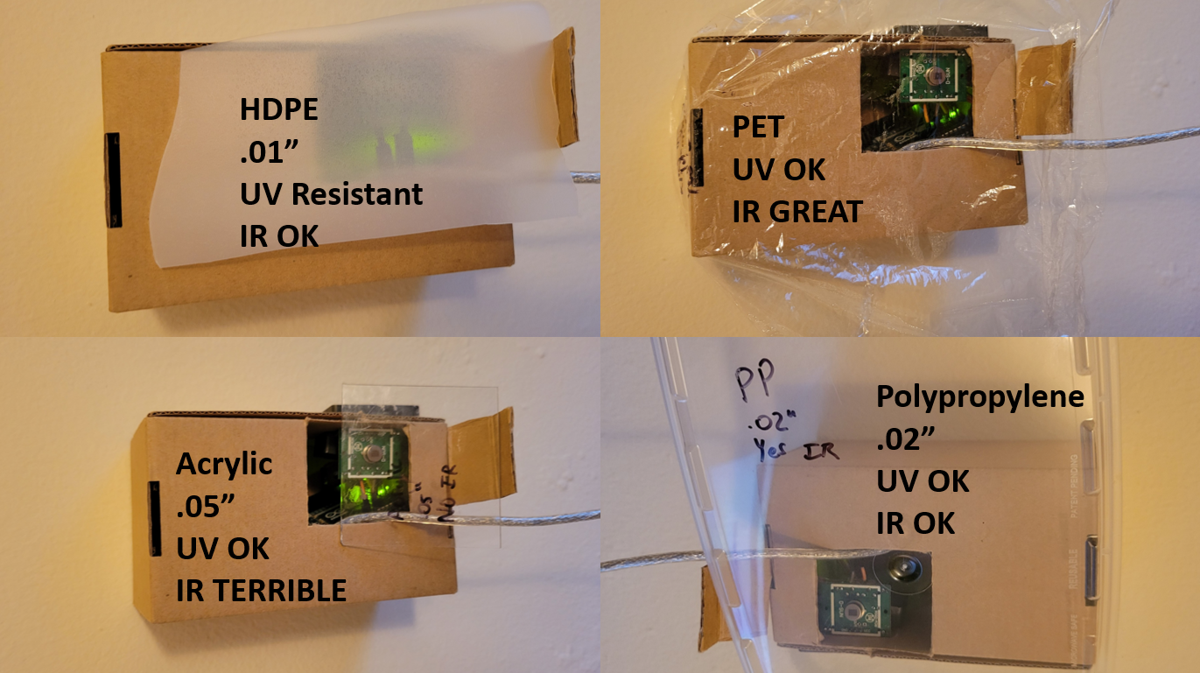

Figure 5: Experimental Results for PIR Testing

The next challenge was creating a strong, well-sealed enclosure that could be operated by anyone without tools. I did some research [3] to see what others have done in this realm. The best way to minimize cost, the possibility of failure, and the complexity is to have fewer parts. I chose to have a hook-like hinge with zero moving parts. Shown in *Figure 6,* the latch, acting similarly to a compliant mechanism, squeezes down on the other side. It took 3 iterations to get hinge – latch combination to work well. Instead of mating two hard surfaces, there is a ¼” silicone tube that goes around the perimeter of the enclosure, in the tube channel. When the enclosure is closed, it compresses the tube and forms a seal between the two parts.

**Tube channel**

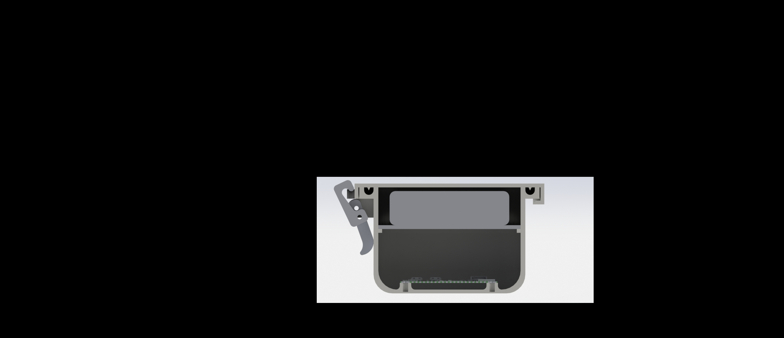

**Electronics**

**Latch**

**Hinge**

**Battery**

Figure 6: Cross-sectional View of Enclosure from Top

Positioning the enclosures to point at the same area is a necessary aspect of the system. To address this, the enclosure utilizes a gimbal (*figure 7).* A 1” nylon strap goes through the end of the gimbal and wraps around whatever the enclosure is attached to (e.g. branch, pole). The gimbal allows the enclosure to swivel about 150 degrees in any direction then be locked in position. This allows extra freedom when placing the enclosure.

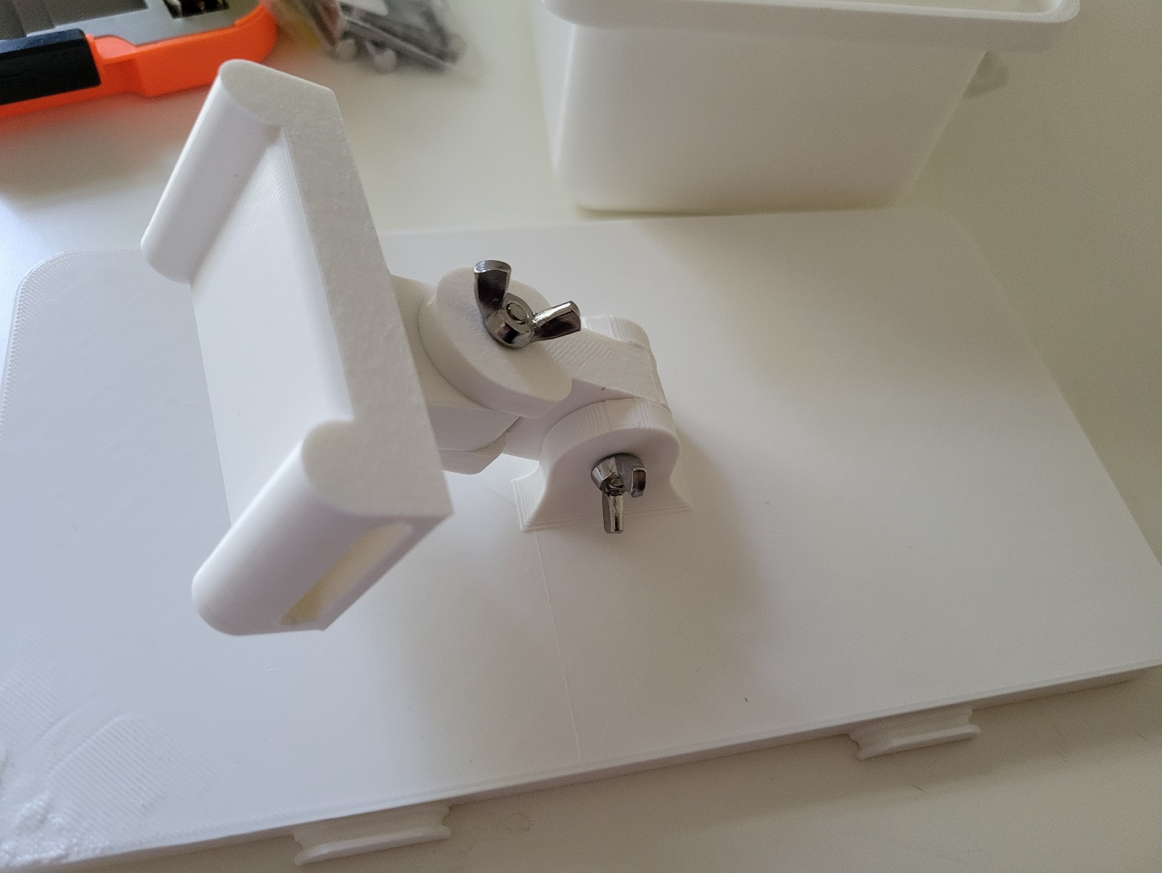

Figure 7: 2-Axis Gimbal

**Documentation**

Over the course of the semester, I achieved what I set out to do: design and build 3 units then prove functionality [5]. I put together work instructions (uploaded to GitHub) that explain the 3D printing, ordering of all the parts, and assembly of the hardware. All parts and sources are in the itemized BOM. There is also a document put together by the SDP team that describes the process of loading the RPis with the software necessary to run the system. Following the documentation, one should be able to put together a NetCams system.

**Testing**

When the enclosure design was finalized, I printed and assembled three of them. There are several things that are important to test for: how easy it is to assemble, how easy it is to set the system up in the field, how weatherproof the enclosure is, and if the system can detect and take pictures of animals.

Assembling the enclosure is relatively pain-free, and as I stated above, is covered in depth in the work instructions. The first enclosure took the longest, at about an hour, but by the third, it only took about 20 minutes. To test the ease of use of the physical system, I brought the enclosures outside and set them up how one would in the field. Setting up 3 enclosures, including SSH-ing into the system and running all the programs, takes about 20 minutes. It’s reasonable to expect an additional 5 minutes per enclosure. This should only get faster the more experience a user has with NetCams.

Once the system is up and running, it can be left alone for a few days depending on the temperature conditions. There are two programs that can be run: single-sensor and multi-sensor. The single-sensor program triggers a photo when the masters PIR sensor is triggered. The multi-sensor program is the one explained above; it only triggers when at least 2/3 of the sensors are triggered. The single sensor program is easier to trigger but it is very difficult to guarantee enough usable photos if only 1 sensor is triggered. The multi-sensor program can be difficult to trigger, especially with only 3 enclosures, but when it triggers, it usually collects images of the subject from all angles.

Shown below are 3 separate test scenarios. In *Figures 8 and 9*, I am the subject. The program being run is the single-sensor program, so only the master (frame 1) needs to be triggered. In *Figure 8*, I walk into the frame. It is clear that I’m not well captured. In the first frame, only about half of my body is pictured, the second, my entire body is in there, but it is pictured from afar. I am not even captured in frame three. In *Figure 9*, the master was triggered while I was standing in the frame, so I was captured well by every unit in the system. *Figure 10* was captured using the multi-sensor program; it did a great job at capturing the moving subject. For a similar amount of attempts, 20 - 25, the single-sensor program captured 19 sets of photos while the multi-sensor program captured 6. It is worth noting that while testing the single-sensor program, I, an actual heat-emitting mammal, was the test subject. For a majority of the multi-sensor testing, I used a stuffed moose with water bottles filled with hot water (~90C) to trigger the sensors. There were multi-sensor trials where I was the subject, but they will be addressed later.

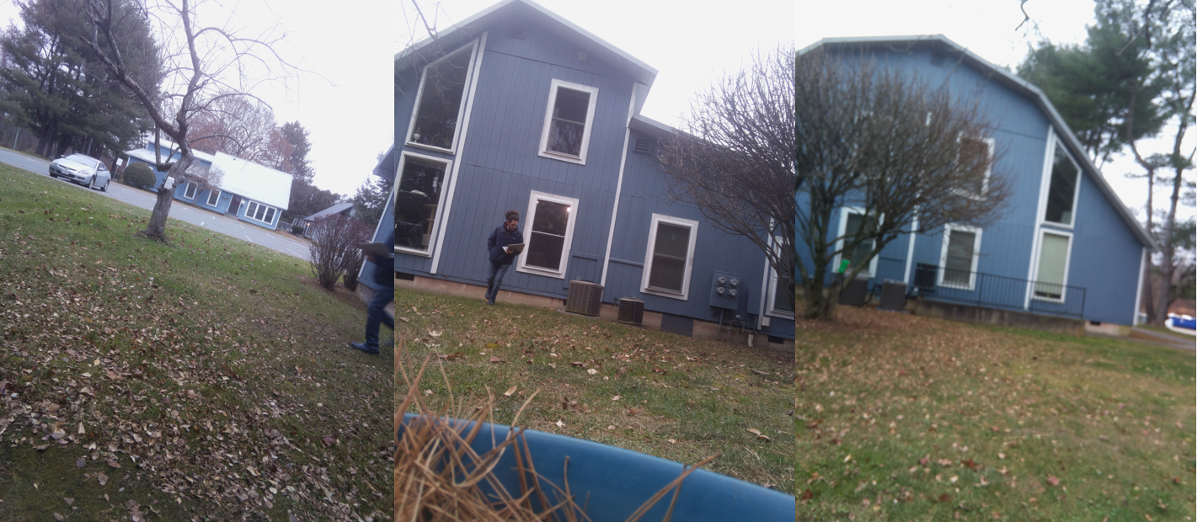

Figure 8: Single Sensor, Walking into the Frame

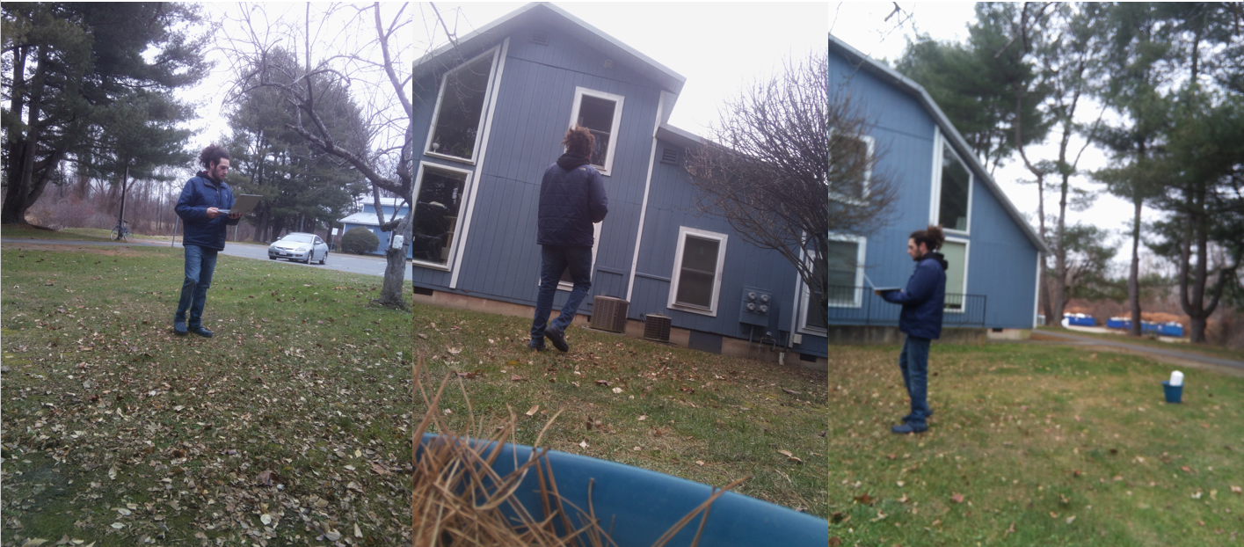

Figure 9: Single Sensor, Standing in Frame

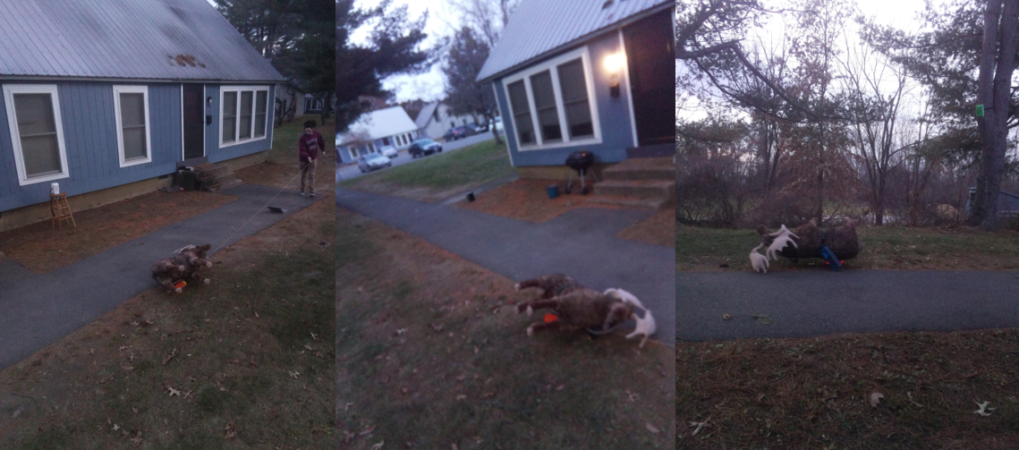

Figure 10: Multi-sensor, Walking into Frame

Not much weather testing has been done on the enclosure. The simplest test that can be done is leaving a working enclosure outside for a week, letting it see some rain, snow, or high wind, then coming back and making sure it still works. If NetCams goes into mass production, a higher level of testing will be necessary. Following the IP rating standard [6], I recommend testing for a rating of IP61.

**What Can be Improved?**

In its current state, the system is absolutely usable, but there are points that could be improved. Setting the system up can be a little bit demanding because you have to SSH into every unit to run the program. Doing this for three units felt like a lot, doing it for 10 or 20 would be extremely annoying. Setting up the RPi with a program that runs automatically or with the press of a button would be very helpful.

Once the system was set up and running, taking pictures on purpose was a bit tricky. For the multi-sensor program, between each set of photos, there was a 30 second break; this is due to the fact that the PIR sensors need to adjust to the ambient heat. I’m not sure what a work-around to this would look like, but it was a little bit frustrating. Another timing issue was the 10 second window when the system would wait to be triggered; I’m not sure if it was looking simultaneously or just at any point during the 10 seconds, but while jogging through at about 7 mph, I was never picked up by the system.

Transferring photos, while made convenient by the app, was sometimes a little buggy. The first problem I ran into is that it saves the photos to the phones download folder as ‘set 1, set 2... set n’. When you don’t delete the last run of photos from the download folder, it terminates the transfer of the photos, but it doesn’t kill the server that gets set up. This results in an inability to start the FTP again, and means you need to reboot the system. Rebooting the system has resulted in me losing hours of data. If I were a biologist, and I lost three days’ worth of data because of this, I’d be upset. Creating some fail-safe, photo backup on the master RPi might be worthwhile.

Lastly, this enclosure is 3D printed. While this has been fantastic for prototyping and could even work for low scale (<1000) units, I don’t think it would be great for mass production. If this product makes its way to market, the enclosure needs to be redesigned to be either cast urethane or injection molded. Otherwise, the time to make all of the custom pieces would be a massive bottleneck.

**Conclusion**

Throughout the course of the Fall 2021 semester, I set out to design the enclosure for the NetCams system with the intent for it to be weatherproof and not to hinder the function of the electronics. I built three enclosures, tested their ability to take pictures, and documented the entire process. I was able to design a repeatably manufacturable and easy to use enclosure. While the system does work, there is plenty of room for improvement, especially with regards to software. I really enjoyed working on this project and I am very proud of the results.

Sources:

[1] *Fresnel lens. (2021, November 25). Retrieved from https://en.wikipedia.org/wiki/Fresnel_lens#:~:text=A Fresnel lens is a,1827) for use in lighthouses.&text=A Fresnel lens can be,form of a flat sheet*

[2]<https://components101.com/sites/default/files/component_datasheet/HC%20SR501%20PIR%20Sensor%20Datasheet.pdf>

[3] *Water Resistant 3D Printed Enclosures. (n.d.). Retrieved from https://hackaday.io/project/174011-water-resistant-3d-printed-enclosures*

[4] Itemized BOM, located in GitHub

[5] Independent Study Form, located in GitHub

[6] *What are IP Ratings? (2019, June 12). Retrieved from https://www.polycase.com/techtalk/learningcenter/ip-ratings*